Lituus
# Source: AI Source: Provided by: [Data Path: Persons Table -> ID Column: 1, Name_En Column: Motasem Essam] -> From: [ChatGPT] on [7/25/2026]
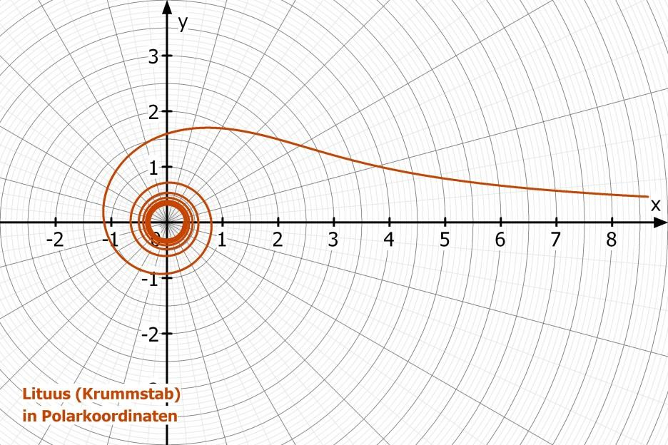
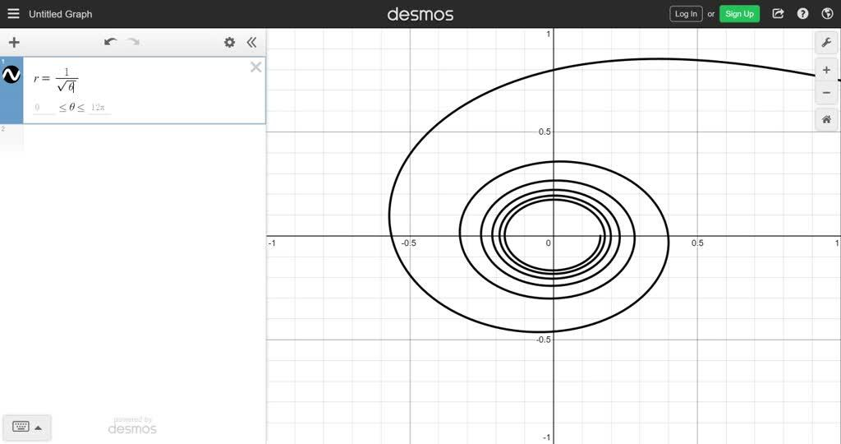
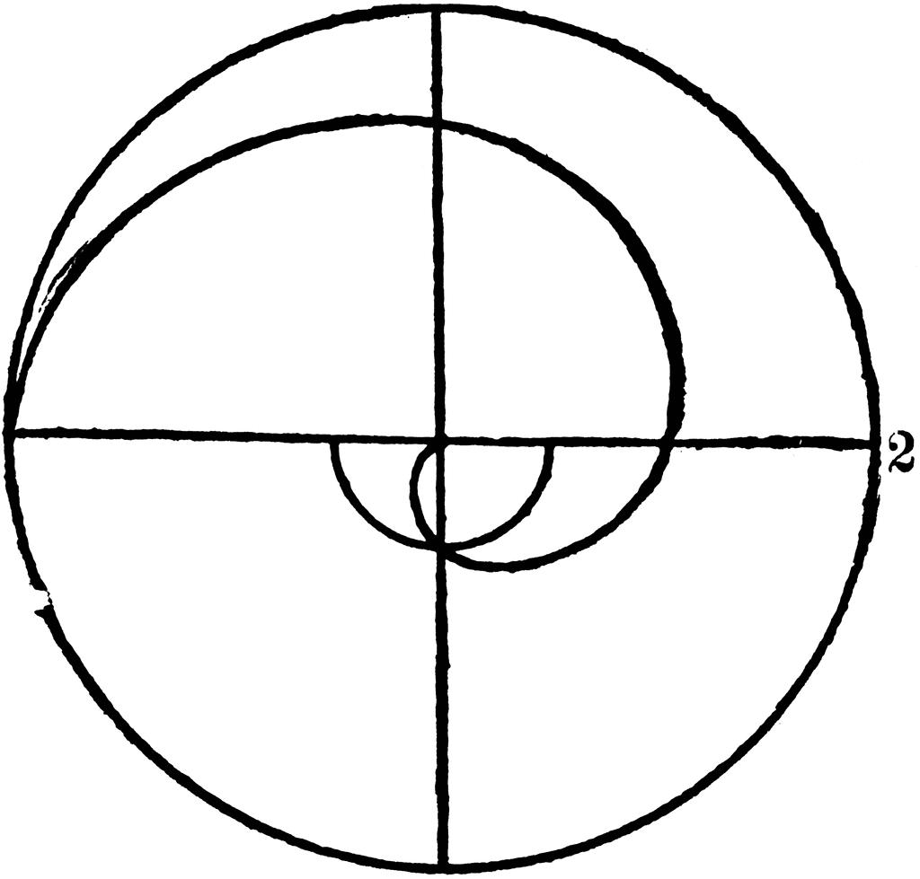

Definition
# Source: AI Source: Provided by: [Data Path: Persons Table -> ID Column: 1, Name_En Column: Motasem Essam] -> From: [ChatGPT] on [7/25/2026]
A Lituus is a type of spiral in which the radial distance from the pole is inversely proportional to the square root of the angle.
Its standard polar equation is:
$$\boxed{r=\frac{a}{\sqrt{θ}}}$$
where:
- $r$= radial distance from the pole
- $θ$= angular position
- $a$= positive constant controlling the scale of the spiral
- $θ>0$
The defining relationship can also be written as:
$$\boxed{r^{2}θ=a^{2}}$$

Fundamental Concept
# Source: AI Source: Provided by: [Data Path: Persons Table -> ID Column: 1, Name_En Column: Motasem Essam] -> From: [ChatGPT] on [7/25/2026]
The Lituus follows an inverse square-root relationship:
$$\boxed{r∝\frac{1}{\sqrt{θ}}}$$
Therefore:
$$\boxed{r^{2}∝\frac{1}{θ}}$$
As $θ$increases, $r$decreases.
For example, if:
$$r=\frac{4}{\sqrt{θ}}$$
then:

$$θ$$ | $$r$$
$$1$$ | $$4$$
$$4$$ | $$2$$
$$9$$ | $$1.33$$
$$16$$ | $$1$$
$$25$$ | $$0.8$$
Thus, multiplying the angle by $4$divides the radius by $2$.

Basic Structure
# Source: AI Source: Provided by: [Data Path: Persons Table -> ID Column: 1, Name_En Column: Motasem Essam] -> From: [ChatGPT] on [7/25/2026]
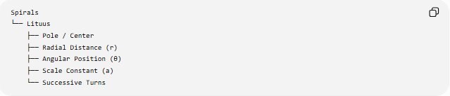
Spirals
└── Lituus
├── Pole / Center
├── Radial Distance (r)
├── Angular Position (θ)
├── Scale Constant (a)
└── Successive Turns
The defining relationship is:
$$\boxed{r^{2}θ=a^{2}}$$

Standard Mathematical Representation
# Source: AI Source: Provided by: [Data Path: Persons Table -> ID Column: 1, Name_En Column: Motasem Essam] -> From: [ChatGPT] on [7/25/2026]
Polar Equation
$$\boxed{r=\frac{a}{\sqrt{θ}}}$$
Squaring:
$$r^{2}=\frac{a^{2}}{θ}$$
Therefore:
$$\boxed{r^{2}θ=a^{2}}$$
and:
$$\boxed{θ=\frac{a^{2}}{r^{2}}}$$

Parametric Form
Using:
$$x=r\cos{θ}$$
and:
$$y=r\sin{θ}$$
we obtain:
$$\boxed{x=\frac{a\cos{θ}}{\sqrt{θ}}} \\ \boxed{y=\frac{a\sin{θ}}{\sqrt{θ}}}$$

Radial Behavior
# Source: AI Source: Provided by: [Data Path: Persons Table -> ID Column: 1, Name_En Column: Motasem Essam] -> From: [ChatGPT] on [7/25/2026]
Starting with:
$$r=aθ^{-1/2}$$
differentiate with respect to $θ$:
$$\boxed{\frac{dr}{dθ}=-\frac{a}{2θ^{3/2}}}$$
For $a>0$and $θ>0$:
$$\frac{dr}{dθ}<0$$
Therefore, the radius decreases as the angle increases.
Furthermore:
$$\lim_{θ→∞}r=0$$
so:
$$\boxed{r→0}$$
The Lituus therefore winds progressively closer to the pole.

Behavior Near the Pole
# Source: AI Source: Provided by: [Data Path: Persons Table -> ID Column: 1, Name_En Column: Motasem Essam] -> From: [ChatGPT] on [7/25/2026]
As:
$$θ→0^{+}$$
we have:
$$r=\frac{a}{\sqrt{θ}}→∞$$
Therefore:
$$\boxed{\lim_{θ→0^{+}}r=∞}$$
This means the standard branch of the Lituus extends arbitrarily far from the pole for angles approaching zero, while approaching the pole as the angle becomes very large.

Number of Turns
# Source: AI Source: Provided by: [Data Path: Persons Table -> ID Column: 1, Name_En Column: Motasem Essam] -> From: [ChatGPT] on [7/25/2026]
The number of complete revolutions over an angular interval is:
$$\boxed{N=\frac{Δθ}{2π}}$$
For example, an angular change of:
$$8π$$
corresponds to:
$$N=\frac{8π}{2π}=4$$
complete turns.

Radius After One Complete Revolution
# Source: AI Source: Provided by: [Data Path: Persons Table -> ID Column: 1, Name_En Column: Motasem Essam] -> From: [ChatGPT] on [7/25/2026]
One revolution corresponds to:
$$Δθ=2π$$
At angle $θ$:
$$r_{1}=\frac{a}{\sqrt{θ}}$$
After one revolution:
$$r_{2}=\frac{a}{\sqrt{θ+2π}}$$
Therefore:
$$\boxed{\frac{r_{2}}{r_{1}}=\sqrt{\frac{θ}{θ+2π}}}$$
The radial difference is:
$$\boxed{Δr=a\left(\frac{1}{\sqrt{θ+2π}}-\frac{1}{\sqrt{θ}}\right)}$$
Its magnitude becomes smaller as the spiral approaches the pole.

Area Swept by the Spiral
# Source: AI Source: Provided by: [Data Path: Persons Table -> ID Column: 1, Name_En Column: Motasem Essam] -> From: [ChatGPT] on [7/25/2026]
For a polar curve:
$$A=\frac{1}{2}\int_{θ_{1}}^{θ_{2}}{r^{2}} dθ$$
For the Lituus:
$$r^{2}=\frac{a^{2}}{θ}$$
Therefore:
$$A=\frac{a^{2}}{2}\int_{θ_{1}}^{θ_{2}}{\frac{1}{θ}} dθ$$
giving:
$$\boxed{A=\frac{a^{2}}{2}\ln\left(\frac{θ_{2}}{θ_{1}}\right)}$$
for:
$$0<θ_{1}<θ_{2}$$

Important Area Property
# Source: AI Source: Provided by: [Data Path: Persons Table -> ID Column: 1, Name_En Column: Motasem Essam] -> From: [ChatGPT] on [7/25/2026]
The area swept over equal multiplicative changes in angle is constant.
For example, if the angular intervals are:
$$\left[θ , 2θ\right]$$
then:
$$A=\frac{a^{2}}{2}\ln{2}$$
If the interval is:
$$\left[2 , θ4θ\right]$$
then:
$$A=\frac{a^{2}}{2}\ln{2}$$
Therefore:
$$\boxed{A_{\left[θ , 2θ\right]}=A_{\left[2 , θ4θ\right]}}$$
This is a characteristic consequence of the Lituus equation.

Arc Length
# Source: AI Source: Provided by: [Data Path: Persons Table -> ID Column: 1, Name_En Column: Motasem Essam] -> From: [ChatGPT] on [7/25/2026]
For a polar curve:
$$L=\int_{θ_{1}}^{θ_{2}}{\sqrt{r^{2}+{\left(\frac{dr}{dθ}\right)}^{2}}} dθ$$
For:
$$r=\frac{a}{\sqrt{θ}}$$
we have:
$$\frac{dr}{dθ}=-\frac{a}{2θ^{3/2}}$$
Therefore:
$$L=\int_{θ_{1}}^{θ_{2}}{\sqrt{\frac{a^{2}}{θ}+\frac{a^{2}}{4θ^{3}}}} dθ$$
or:
$$\boxed{L=∣a∣\int_{θ_{1}}^{θ_{2}}{\frac{\sqrt{4θ^{2}+1}}{2θ^{3/2}}} dθ}$$
The arc length is more complicated than the basic area expression.

Important Properties
# Source: AI Source: Provided by: [Data Path: Persons Table -> ID Column: 1, Name_En Column: Motasem Essam] -> From: [ChatGPT] on [7/25/2026]
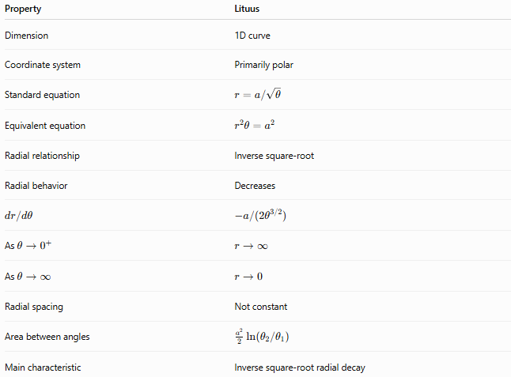
Property | Lituus
Dimension | 1D curve
Coordinate system | Primarily polar
Standard equation | $$r=a/\sqrt{θ}$$
Equivalent equation | $$r^{2}θ=a^{2}$$
Radial relationship | Inverse square-root
Radial behavior | Decreases
$$dr/dθ$$ | $$-a/\left(2θ^{3/2}\right)$$
As $θ→0^{+}$ | $$r→∞$$
As $θ→∞$ | $$r→0$$
Radial spacing | Not constant
Area between angles | $$\frac{a^{2}}{2}ln⁡\left(θ_{2}/θ_{1}\right)$$
Main characteristic | Inverse square-root radial decay

Lituus vs Other Spirals
# Source: AI Source: Provided by: [Data Path: Persons Table -> ID Column: 1, Name_En Column: Motasem Essam] -> From: [ChatGPT] on [7/25/2026]
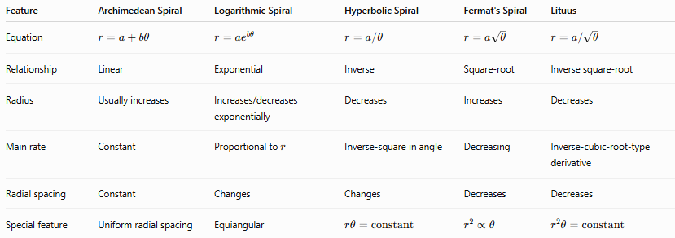
Feature | Archimedean Spiral | Logarithmic Spiral | Hyperbolic Spiral | Fermat's Spiral | Lituus
Equation | $$r=a+bθ$$ | $$r=ae^{bθ}$$ | $$r=a/θ$$ | $$r=a\sqrt{θ}$$ | $$r=a/\sqrt{θ}$$
Relationship | Linear | Exponential | Inverse | Square-root | Inverse square-root
Radius | Usually increases | Increases/decreases exponentially | Decreases | Increases | Decreases
Main rate | Constant | Proportional to $r$ | Inverse-square in angle | Decreasing | Inverse-cubic-root-type derivative
Radial spacing | Constant | Changes | Changes | Decreases | Decreases
Special feature | Uniform radial spacing | Equiangular | $$rθ=\text{constant}$$ | $$r^{2}∝θ$$ | $$r^{2}θ=\text{constant}$$
The most useful algebraic comparison is:
$$\boxed{\text{Fermat: }r^{2}∝θ}$$
while:
$$\boxed{\text{Lituus: }r^{2}∝\frac{1}{θ}}$$

Example
# Source: AI Source: Provided by: [Data Path: Persons Table -> ID Column: 1, Name_En Column: Motasem Essam] -> From: [ChatGPT] on [7/25/2026]
Consider:
$$\boxed{r=\frac{6}{\sqrt{θ}}}$$
At:
$$θ=1 \\ r=6$$
At:
$$θ=4 \\ r=3$$
At:
$$θ=9 \\ r=2$$
At:
$$θ=36 \\ r=1$$
Therefore:
$$θ↑ ⟹ r↓$$
and:
$$r→0$$
as:
$$θ→∞$$

Important Distinction
# Source: AI Source: Provided by: [Data Path: Persons Table -> ID Column: 1, Name_En Column: Motasem Essam] -> From: [ChatGPT] on [7/25/2026]
The Lituus should not be confused with the Hyperbolic Spiral.
Hyperbolic Spiral
$$\boxed{r=\frac{a}{θ}}$$
Lituus
$$\boxed{r=\frac{a}{\sqrt{θ}}}$$
The difference is the power of $θ$:
$$\boxed{\text{Hyperbolic: }r∝θ^{-1}} \\ \boxed{\text{Lituus: }r∝θ^{-1/2}}$$
The Lituus therefore decreases more slowly with angle than the Hyperbolic Spiral.

Classification
# Source: AI Source: Provided by: [Data Path: Persons Table -> ID Column: 1, Name_En Column: Motasem Essam] -> From: [ChatGPT] on [7/25/2026]
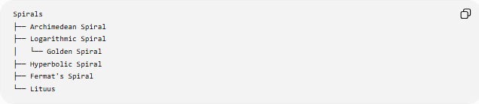
Spirals
├── Archimedean Spiral
├── Logarithmic Spiral
│ └── Golden Spiral
├── Hyperbolic Spiral
├── Fermat's Spiral
└── Lituus
The Lituus is treated as a distinct named spiral family in this classification.
“Outward Lituus” and “Inward Lituus” can be used descriptively depending on the direction in which the curve is traversed, but they are not separate fundamental spiral types.

Key Points
# Source: AI Source: Provided by: [Data Path: Persons Table -> ID Column: 1, Name_En Column: Motasem Essam] -> From: [ChatGPT] on [7/25/2026]
- Lituus is a spiral with an inverse square-root relationship between radius and angle.
- Its standard equation is:
$$\boxed{r=\frac{a}{\sqrt{θ}}}$$
- Equivalently:
$$\boxed{r^{2}θ=a^{2}}$$
- As $θ$increases, $r$decreases.
- As $θ→∞$:
$$\boxed{r→0}$$
- As $θ→0^{+}$:
$$\boxed{r→∞}$$
- The area between two angles is:
$$\boxed{A=\frac{a^{2}}{2}\ln\left(\frac{θ_{2}}{θ_{1}}\right)}$$
- It differs from the Hyperbolic Spiral by having $1/\sqrt{θ}$rather than $1/θ$.
- It differs from Fermat's Spiral because Fermat's Spiral has $r∝\sqrt{θ}$, whereas the Lituus has $r∝1/\sqrt{θ}$.

Conclusion
# Source: AI Source: Provided by: [Data Path: Persons Table -> ID Column: 1, Name_En Column: Motasem Essam] -> From: [ChatGPT] on [7/25/2026]
A Lituus is a spiral defined by the inverse square-root relationship
$$\boxed{r=\frac{a}{\sqrt{θ}}}$$
or:
$$\boxed{r^{2}θ=a^{2}}$$
As the angular position increases, the spiral approaches the pole, while for angles approaching zero from the positive side, its radial distance becomes arbitrarily large. Its inverse-square-root behavior places it between the stronger inverse decay of the Hyperbolic Spiral and the square-root growth relationship of Fermat's Spiral.

